6 November 2023

To whom it may concern,

Consultation on admission arrangements for [insert name of school], for the year 2025/2026

The Diocese of Gloucester Academies Trust (DGAT) acting in its role as admission authority for [name of school] is currently determining proposed admission arrangements for admissions to the school in September 2025. As determined by the School Admissions Code, the Trust is required to consult on these arrangements, and invites comments on the proposed changes.

A copy of the proposed admissions policy is available on the DGAT website for your information.

Alternatively, if you require a hard copy of the policy please contact Nicki Wadley, the Trust’s head of governance and people directly at contactus@cen.dgat.org.uk with Admissions Policy Request as the email title.

The Trust Board is proposing to implement a single admissions policy across the Trust which will require amendments to the school’s current admissions arrangements.

Current admissions arrangements across the Trust
Each DGAT school currently has its own admissions arrangements, decided upon by the school’s local governing board, however, the statutory responsibility for admissions arrangements rests with the Trust Board. As a Trust we have always encouraged schools to follow the GCC admissions arrangements as we recognise these reflect statutory guidance set out within the School Admissions Code.

Review process
All schools’ published admissions arrangements for 2024/25 were collated and reviewed. An internal stakeholder consultation took place, with the option for schools to complete a survey or attend one of two drop-in sessions. The Trust also informally discussed its review and proposals under consideration with the chair of the Diocesan Board of Education and the Church of England Education Office and these views were considered by the Trust Board in the decision-making process.

Proposed changes being consulted on

- The Trust Board is proposing to remove the faith criteria for entry to the schools within the Trust where this applies. This is to promote and recognise the school as a wholly inclusive and welcoming school for all, reflecting the Church of England vision that education is generous and seeks to allow the riches of Christian life to overflow to those of other faiths or no faith. This change will not have any impact on the Christian distinctiveness of the school or the education that we provide.

- To include a staff criterion in the admissions policy over-subscription criteria. This change is intended to support the recruitment and retention of staff within the school and wider Trust and to bring equity for all staff employed by the Trust. Within current admissions arrangements across the Trust, some schools have a staff criterion within the oversubscription criteria, but others don’t. As a single employer, the Trust Board considers it important to have equity for all staff employed within our family of schools.

- To remove the medical need criterion from those schools’ admissions arrangements which include this. This is a historic admissions criterion that is not included in the current recommended admissions arrangements by Gloucestershire County Council (GCC).

- All DGAT schools to use the GCC computerised distance measuring tool where distance is applied in the over-subscription criteria.

If you wish to comment on the proposed admissions arrangements, please send your response in writing for the attention of Nicki Wadley, head of governance and people either by post to; No. 3 College Green, Gloucester, GL1 2LR or by email to nwadley@cen.dgat.org.uk – please add ‘Admissions consultation comment’ to the email subject header. Comments should be received by no later than 9am on Monday 18 December 2023.

Yours sincerely

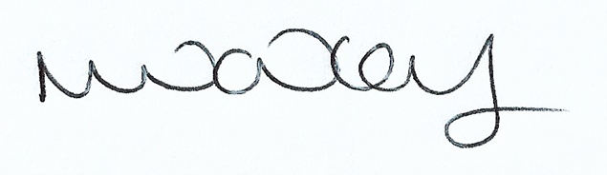

Nicki Wadley
Head of governance and people

