COMMUNICATION, LANGUAGE AND LITERACY  Term 3: The Blue Penguin – Petr Horácek – Power of reading unit  Term 4: Supertato – Sue Hendra and Paul Linnet  Daily story time altogether, sharing picture books and simple chapter books.  Word of the day – the class identifies a word of the day for class collection. The word is explained in everyday language and the class uses the word in different contexts.  Circle Time – sharing news and speaking in sentences, talking about what we are doing, what we are thinking, how we are feeling  LETTERS AND SOUNDS  Reception Phase 2/3  Year 1 Revision of Phase 3 and 4 - Phase 5  Correct pencil grip encouraged when using pencils for writing and drawing and coloured pencils for colouring in. Letter formation practise  How to help at home.  Please share your child’s choosing and reading books with them. Write a comment in their reading record at least five times each week. Reading books needs to be in school everyday please.  Play rhyming and I Spy games. Practise tricky words.  Reception - Please continue to practise phase 2 and/or phase 3 phonemes at home and read the word lists on the back of the phoneme sheets. If you have magnetic letters use them to make the words on the lists.  Alphablocks - BBC  Phonics Play: Phase 2 Word Games  ICT Games: Literacy Games  Oxford Owl: Reading Activities  PHYSICAL DEVELOPMENT  Dance – Perform movement to music: Winter by Vivaldi  Gym  Football  Use of outdoor equipment – balls, beanbags, bikes and scooters, Woodhenge and building with scrap.  Throwing and catching skills / kicking and receiving skills.  Listen and respond to action songs.  Daily run around the field. Can we do three laps to run a mile?  Daily fine motor exercises and activities.  Build resilience when playing and learning outside and during outdoor learning.  Parachute Games  How to help at home.  Continue to encourage independence with changing clothes, zipping up coats, opening packets to develop fine motor control. Encourage the children to carry their own bags and take responsibility for their belongings by finding what they need and tidying up or putting things away independently or with support. | PERSONAL, SOCIAL AND EMOTIONAL DEVELOPMENT  Values  Courage  PSHE  Valuing difference  Health and wellbeing  Routines  Kind Hands and Kind Feet  How to help at home.  Encourage independence, discussion about feelings and how we can help one another.  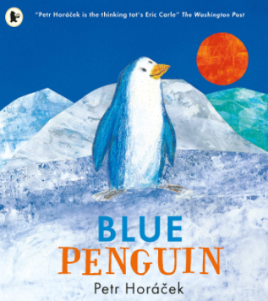  Term 3 – The Blue Penguin  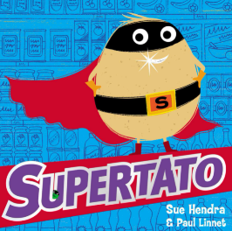  Term 4 - Supertato  ICT Unit 1 We have confidence (recording and playing back sounds). Unit 3 We are successful. Taking photographs and combining them with text and sounds  EXPRESSIVE ART AND DESIGN/DT Term 3/4 Painting from observation and imagination  Neal Layton (illustrator)  Penguins and icy collage pictures  Drawing and painting penguins  Making 3D penguins (y1)  Creating a healthy meal  Making a fruit and yoghurt breakfast (Y1)  Diana Beltran-Herrera  Make a fruit salad (Rec)  Painting from real life and imagination Opportunities for free painting from experience and /or imagination, cutting and sticking activities and model making ongoing… Drama - linked to texts - Hot Seating /Role Play Dance - Movement in nature - observe and move - Autumn - Listen to Vivaldi - Four Seasons Autumn Music - Charanga  Term 3: ‘Our world round and round’ Term 4: ‘Everyone in the groove.’ | MATHS  Reception  - Counting objects 1:1 (one count for each thing)  - Subitising numbers to 5 and beyond  - One more and one less than numbers to 10  - Comparing numbers  - Counting stories and number rhymes  Year 1  - Addition and Subtraction number facts for numbers up to 20  - 3D shapes  - Measurement Length  How to help at home.  - Look out for numbers in the environment, house numbers, road signs, numbers in books.  - Lots of counting e.g. stairs to bed, apples in the fruit bowl, teddies on the bed.  - Use mathematical language such as more/less, smaller/larger, tens ones (Year 1)  UNDERSTANDING OF THE WORLD  Outdoor Learning  Term 1 and Term 2  Signs of Autumn – What have we seen?  Looking for similarities and differences  Collect nuts and seeds to plant  Foraging for fruit - chopping and cooking  Being curious – using our senses  Harvest – Where does food come from?  Making bridges  Science / History / Geography  Term 3 – Penguins and ice (all) British birds (Y1)  Term 4 – life cycle of a frog (all) identifying wild plants and trees (Y1)  Comparing two contrasting places: Minchinhampton and Antarctica (all)  How to help at home. Discuss family history - eg when and where they were born, parents, grandparents and extended family.  Encourage awareness of how we use our five senses.  Encourage discussion about feelings, likes and dislikes, family and friendships.  Look out for fruit, seeds and nuts when out walking and exploring the garden. Plant the seeds they find and watch them grow.  Talk about how the seasons are changing. Discuss where they live and their journey to school.  RE  Reception  Term 3: What times/stories are special and why?  Term 4: Why is Easter special to Christians?  Year 1  Term 3: Who is Muslim and How Do They Live? (Part 2)  Term 4: Why does Easter matter to Christians

