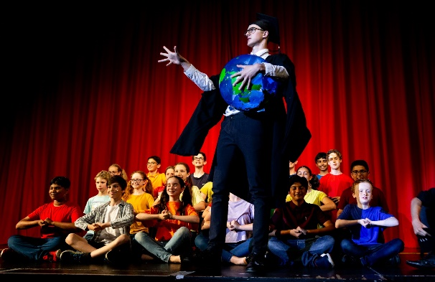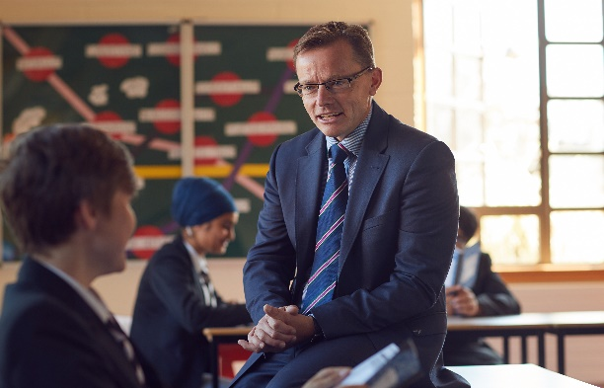****

**Y5 VIRTUAL OPEN MORNINGS 2021**

I would like to invite you to join me at one of our Open Mornings this term. Please note that these will be held online via Microsoft Teams - not in person. We are very disappointed not to be able to welcome you personally to the school, but hope that you will join us live online instead.   
  
**Russel Ellicott, Head Master**  
No booking is required. Simply click one of the dates below – the link will go ‘live’ at 10:30am on each date. There is no need to download the Teams app, just select ‘watch on the web instead’. Very simple.There will be no cameras or mics for attendees, so feel free to relax and enjoy the session as a family.  There will be the opportunity to post questions during the session.

**LIVE LINK:** [**Tuesday 2nd March 2021 at 10:30am**](https://teams.microsoft.com/l/meetup-join/19%3ameeting_YWMyMTA1OTctOTUxMC00MzUyLWEwYzItZmViYmNjN2U3M2Fm%40thread.v2/0?context=%7b%22Tid%22%3a%222e98ed55-402e-46b9-bb19-2fd8184c8256%22%2c%22Oid%22%3a%22485cb81a-ffac-401b-8a45-e2e32f4e98c9%22%2c%22IsBroadcastMeeting%22%3atrue%7d)

**LIVE LINK:** [**Tuesday 30th March 2021 at 10:30am**](https://teams.microsoft.com/l/meetup-join/19%3ameeting_NDYwYTQyZDYtYjYyNi00ZTNhLWI0NGItMmE5YTA4MmNjMDIw%40thread.v2/0?context=%7b%22Tid%22%3a%222e98ed55-402e-46b9-bb19-2fd8184c8256%22%2c%22Oid%22%3a%22485cb81a-ffac-401b-8a45-e2e32f4e98c9%22%2c%22IsBroadcastMeeting%22%3atrue%7d)

Please also see the VIRTUAL TOUR on the front page of our website ([here](https://www.patesgs.org))

Please email [yshelmerdine@patesgs.org](mailto:yshelmerdine@patesgs.org) if you have any queries.

***Pate’s has a strong academic tradition and has, for a number of years, upheld***

***its position as the number one co-educational school in the UK.***