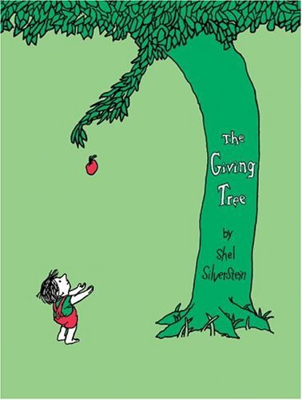**100 Books To Read In KS1**

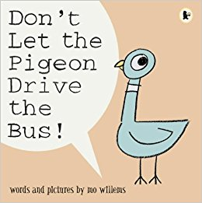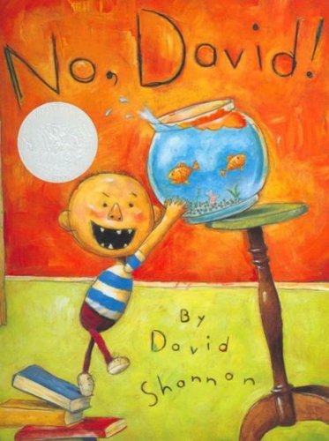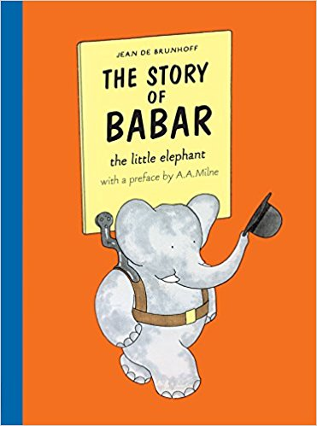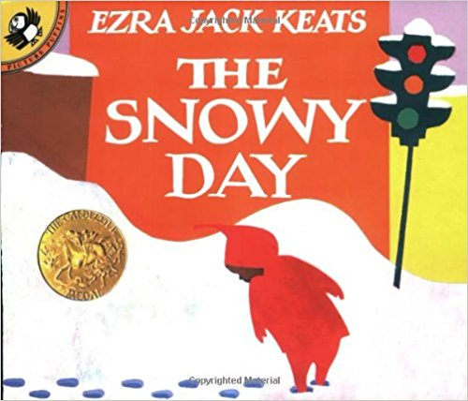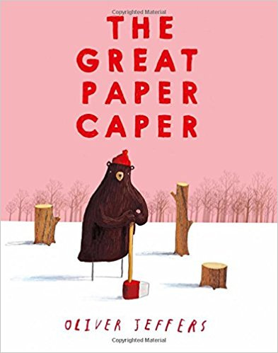

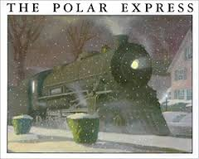

Alexander and the Terrible, Horrible, No Good, Very Bad Day

Judith Viorst

The Whisperer

Nick Butterworth

Guess How Much I Love you

Sam McBratney

The Giving Tree

Shel Silverstein

Who Sank The Boat?

Pamela Allen

Liz Pichon

Knuffle Bunny

Mo Willems

Make Way For Ducklings

Robert McCloskey

Goodnight Moon

Margaret Wise Brown

Don’t Let The Pigeon Drive The Bus

Mo Willems

No, David!

David Shannon

The Polar Express

Chris Van Allsburg

The Story of Babar

Jean De Brunhoff

The Snowy Day

Ezra Jack Keats

The Great Paper Caper

Oliver Jeffers

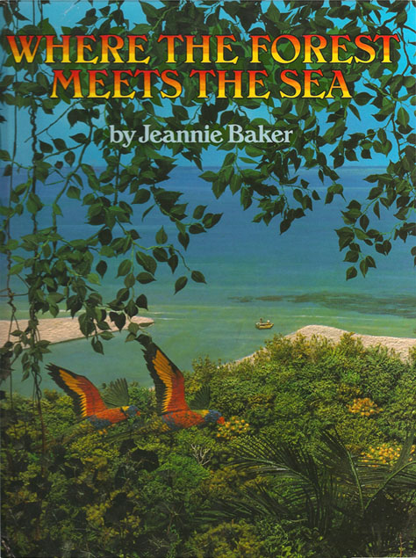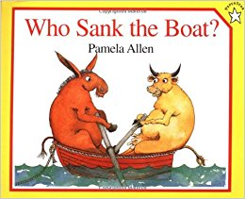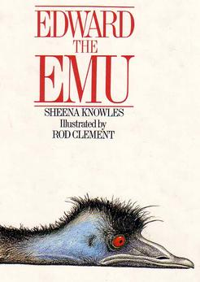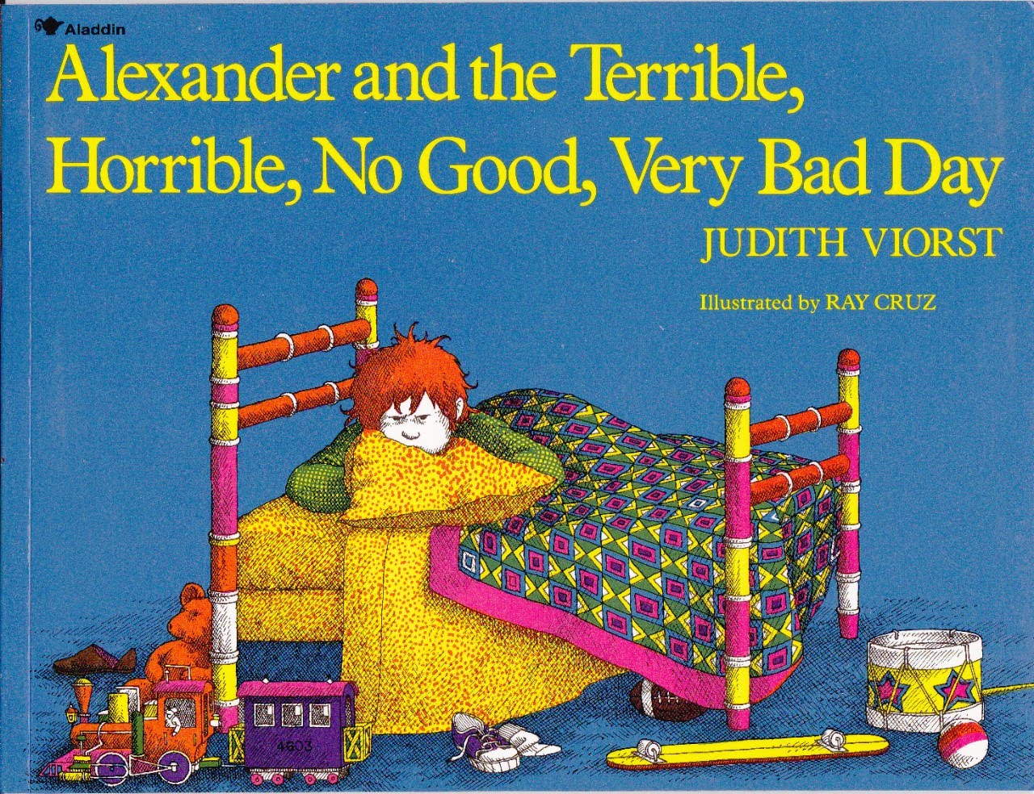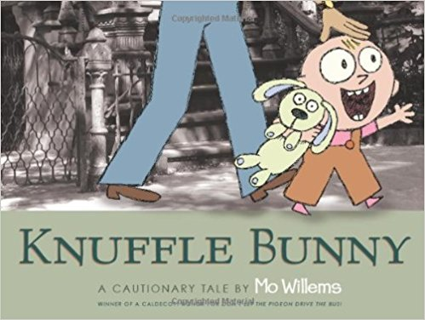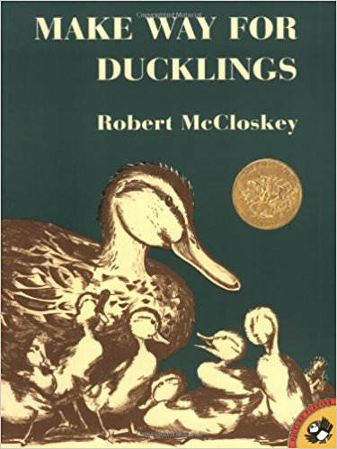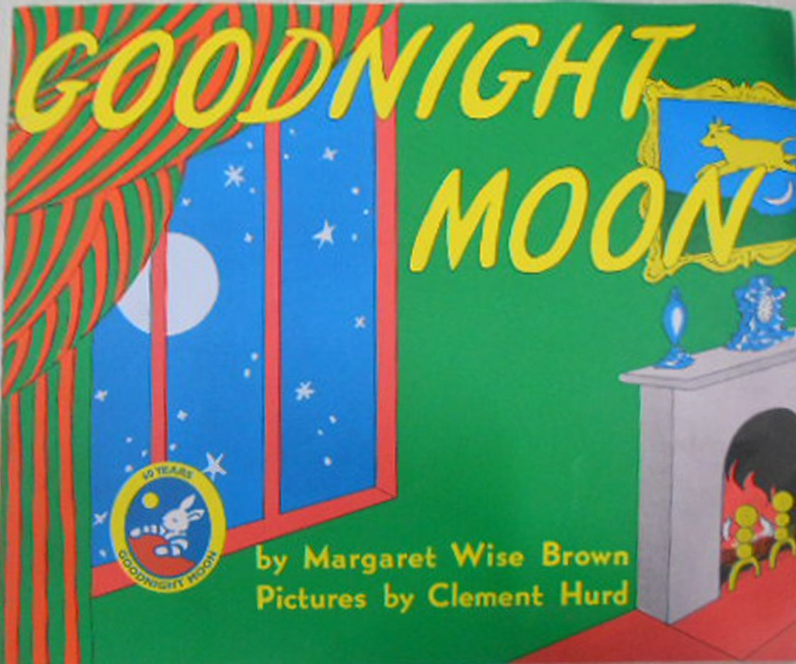

Where The Forest Meets The Sea

Jeannie Baker

Edward The Emu

Sheena Knowles

