**100 Books To Read In Year 3 and 4**

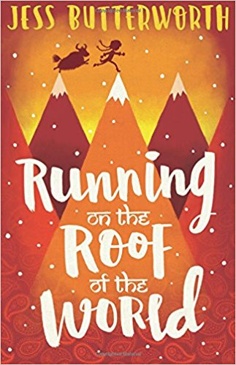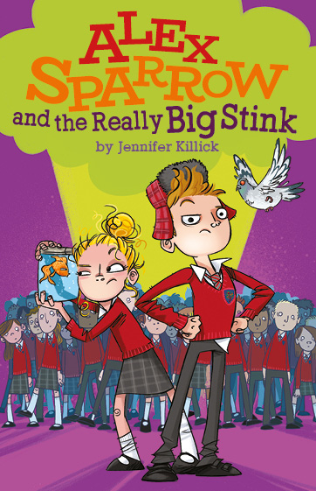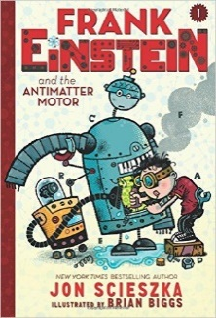 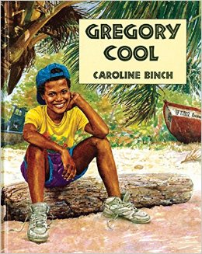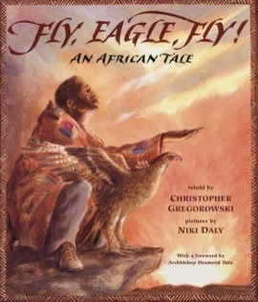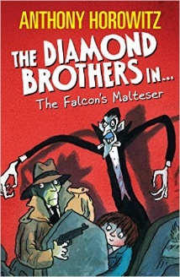

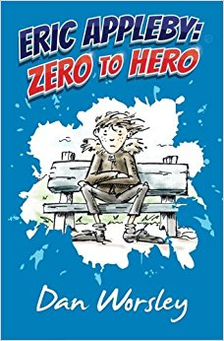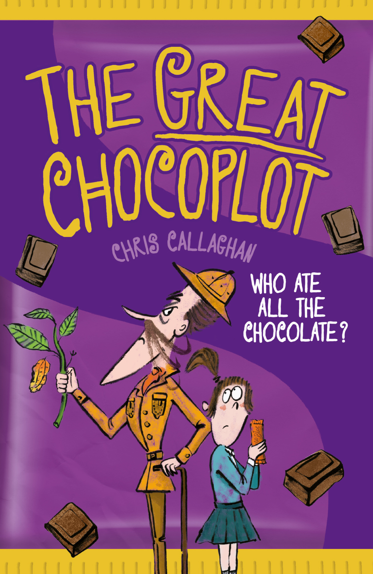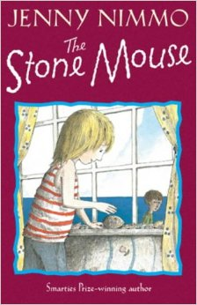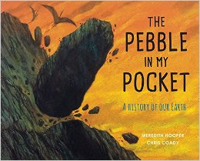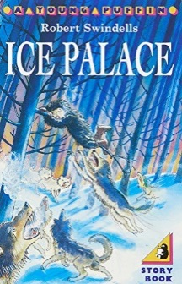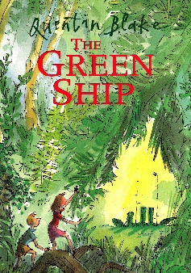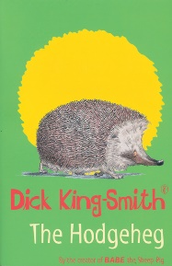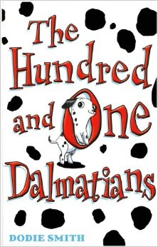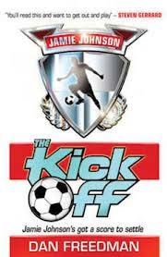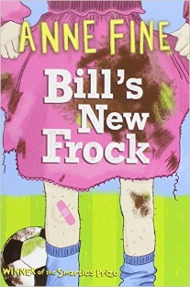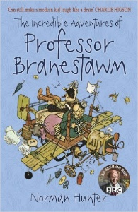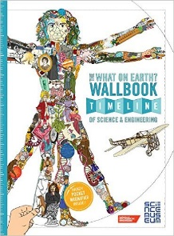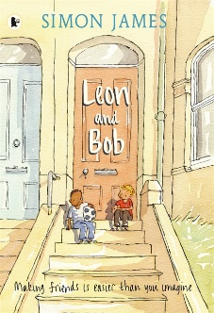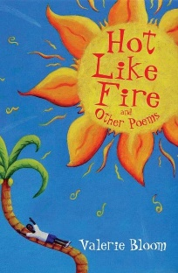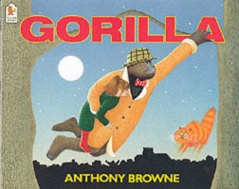**v**

The What On Earth Wallbook

Christopher Lloyd

The Stone Mouse

Jenny Nimmo

The Pebble in my Pocket

Meredith Hooper

Ice Palace

Robert Swindells

The Hodgeheg

Dick King-Smith

The Green Ship

Quentin Blake

The Hundred and One Dalmatians

Dodie Smith

The Kick Off

Dan Freedman

Fly, Eagle Fly!

Christopher Gregorowski

Flour Babies

Anne Fine

The Incredible Adventures of Professor Branestawn

Norman Hunter

Eric Appleby: Zero to Hero  
Dan Worsley

The Great Chocoplot

Chris Callaghan

Leon and Bob

Simon James

Hot Like Fire

Valerie Bloom

Frank Einstein and the Antimatter Motor

Jon Sciezka

Running On The Roof Of The World

Jess Butterworth

Gregory Cool

Caroline Birch

Gorilla

Anthony Browne

The Falcon’s Malteser

Anthony Horowitz

Alex Sparrow and the Really Big Stink

Jennifer Killick