Ideas for dressing up as Victorian school children
For Victorian Day 28th September
We aim to be that Victorian school of 150 years ago—in the way we dress and behave.
There will be a whole school photograph taken in the afternoon-- of us all in Victorian clothes.
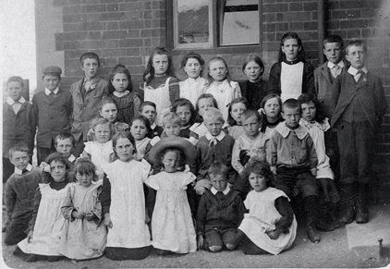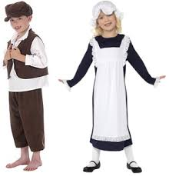

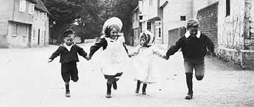

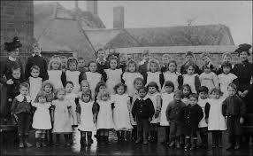

PS- these photos are of Victorian school children—appeared the simplest option for all--- but if you wanted to try something different eg chimney sweep –feel free.

Thank you for your cooperation

