Geography: a study of a non-European country (Malawi in Africa)
Explore human and physical similarities and differences between Minchinhampton and Malawi
PLEASE BE AWARE: This is a help sheet for parents/teachers. Please pick and choose the information that you find interesting and want to share with your child. The children do not need to know all of this (such as the area section) and the language may need to be made more child friendly in places.
Minchinhampton | Malawi
PHYSICAL FEATURES BELOW IN BLUE:
- Minchinhampton: a village on a hilltop in Stroud, which is a part of the county of Gloucestershire. Gloucestershire is a county in England, in the United Kingdom (the UK). The UK is located on the continent of Europe.  - The UK is an island (a piece of land surrounded by water).  - Minchinhampton is near Minchinhampton common (580 acres and a Site of Special Scientific Interest). It is owned by the National Trust (since 1913, before this it had been granted to the people of the town in the 16th century) and is used as summer grazing land for cows. It offers wide views and its mounds formed part of a large Iron Age fort. | - Malawi is a country located on the continent of Africa. There are 54 countries in Africa today. Malawi is found in Eastern Africa. Malawi is a landlocked country, meaning that it is not connected to any ocean.  - Historically, being landlocked has been a disadvantage to a country's development. It cuts a nation off from important sea resources such as fishing, and prevents direct access to maritime trade. Having said this, a fifth of Malawi is made up of water (Lake Malawi).  - The countries that border Malawi are Zambia, Tanzania and Mozambique.
LAKES AND RIVERS:  - The River Severn is the longest river in Great Britain, being 220 miles (354 km) long.  - The largest body of water in the UK is Lough Neagh in Northern Ireland. Loch Ness in Scotland is the largest by volume. Loch Lomond is Scotland's largest lake (surface area), for Wales it is Lake Bala and for England, it is Lake Windermere.  - Can you think of any lakes and rivers by Minchinhampton? | LAKES AND RIVERS:  - Lake Malawi is the fourth largest fresh water lake in the world by volume, the ninth largest lake in the world by area—and the third largest and second deepest lake in Africa. Lake Malawi is home to more species of fish than any other lake.  - There are sometimes arguments between countries over who owns which parts of the lake (Tanzania claims that the international border runs through the middle of the lake. On the other hand, Malawi claims the whole of the surface of this lake that is not in Mozambique, including the waters that are next to the shoreline of Tanzania).  - When it is exceptionally hot, the lake can almost completely dry out.  - The Shire is the largest river and it flows out of Lake Malawi.
MOUNTAINS:  - Minchinhampton is surrounded by common land high above the Chalford valley and there are old cloth mills in the valleys to the south. The common is 679 ft or 207m high.  - Minchinhampton doesn’t have a mountain but Ben Nevis is the highest mountain in the British Isles and it is found in Scotland. It is 4,413 ft or 1,345m tall. | MOUNTAINS:  - Malawi has many mountains. There are 577 peaks. The highest peak is the Sapitwa Peak on Mount Mulanje (9,849 ft or 3,001 m).
AREA:  - UK area: 242,495 km²  - Minchinhampton:? | AREA:  - Malawi: 118,484 km²  - Lilongwe: 727.79 km²
HUMAN FEATURES BELOW IN YELLOW:
POPULATION:  - Minchinhampton has a population of 2, 875 (2011 census).  - The population of the UK is 66.65 million (2019)  - People in the UK have a higher life expectancy. | POPULATION:  - Malawi has a population of 18.63 million (2019).  - Its capital is Lilongwe, which is also Malawi's largest city  - The population of is Lilongwe is 989,318 (2018 census).  - People in Malawi have a lower life expectancy.
SPORTS:  - Minchinhampton is close to a residence of the Princess Royal, Gatcombe Park, which hosts the Gatcombe Horse Trials in late summer each year.  - The rugby club has three adult teams, minis and juniors from under 6 to under 16, and a large touch-rugby section. Minchinhampton RFC plays in the league Gloucester 2 North.  - Minchinhampton Golf Club has three courses. The Cherington and Avening courses are located near villages of the same names, south-east of Minchinhampton. The Old Course is on Minchinhampton Common.  - People can glide at Aston Down. | SPORTS:  - Football is the most common sport in Malawi, introduced there during British colonial rule. Its national team has failed to qualify for a World Cup so far, but have made two appearances in the Africa Cup of Nations.
CUISINE:  - The people of Minchinhampton eat a varied diet. Popular British meals include: Fish and Chips, Bangers and Mash, Full English Breakfast, Sunday Roast, Toad in the Hole, Shepherd's Pie/Cottage Pie and Steak and Kidney Pie. | CUISINE:  - Tea and fish are popular things to eat and drink. Lake Malawi is a source of fish. Nsima is a food staple made from ground corn and typically served with side dishes of meat and vegetables.
CULTURE:  - How would you describe the culture of Minchinhampton? | CULTURE:  - Traditional dances are a strong part of Malawi's culture, and the National Dance Troupe was formed in November 1987 by the government. Traditional music and dances can be seen at marriage ceremonies and celebrations.  - The people of Malawi have a rich tradition of basketry and mask carving, and some of these goods are used in traditional ceremonies still performed by native peoples. Wood carving and oil painting are also popular, with many of the items produced being sold to tourists.  - The country is nicknamed "The Warm Heart of Africa" because of the friendliness of the people.
LANGUAGE:  - The official language is English.  - There is a diverse population, with several other languages spoken and an array of religious beliefs. | LANGUAGE:  - The official language is English, although there are many other languages spoken.  - There is a diverse population of native peoples, Asians and Europeans, many of whom have different religious beliefs.
WILDLIFE:  - Think about the wildlife that we see in the UK and in Minchinhampton. | WILDLIFE:  - Animal life indigenous to Malawi includes mammals such as elephants, hippos, big cats, monkeys, and bats; a great variety of birds including birds of prey, parrots and falcons, waterfowl, owls and songbirds.  - Lake Malawi has been described as having one of the richest lake fish faunas in the world, being the home for some 200 mammal, 650 bird, 30+ mollusc, and 5,500+ plant species.
CLIMATE:  - In general we have warm summers and cool winters. Our summers are cooler than those on the continent of Europe, but the winters are milder.  - Most of the United Kingdom has a temperate climate. The temperature rarely drops below −20 °C or rises above 35 °C.  - Unsettled weather is typical. Many types of weather can be experienced in a single day. In general the climate of the UK is cool and often cloudy and rainy, and high temperatures are infrequent. | CLIMATE:  - Between November and April the temperature is warm with rains and thunderstorms. After March, the rainfall rapidly diminishes and from May to September there is almost no rainfall.
FLAG:  - The UK flag combines aspects of three older national flags: the red cross of St George for the Kingdom of England, the white saltire (diagonal cross) of St Andrew for Scotland and the red saltire (diagonal cross) of St Patrick to represent Ireland.  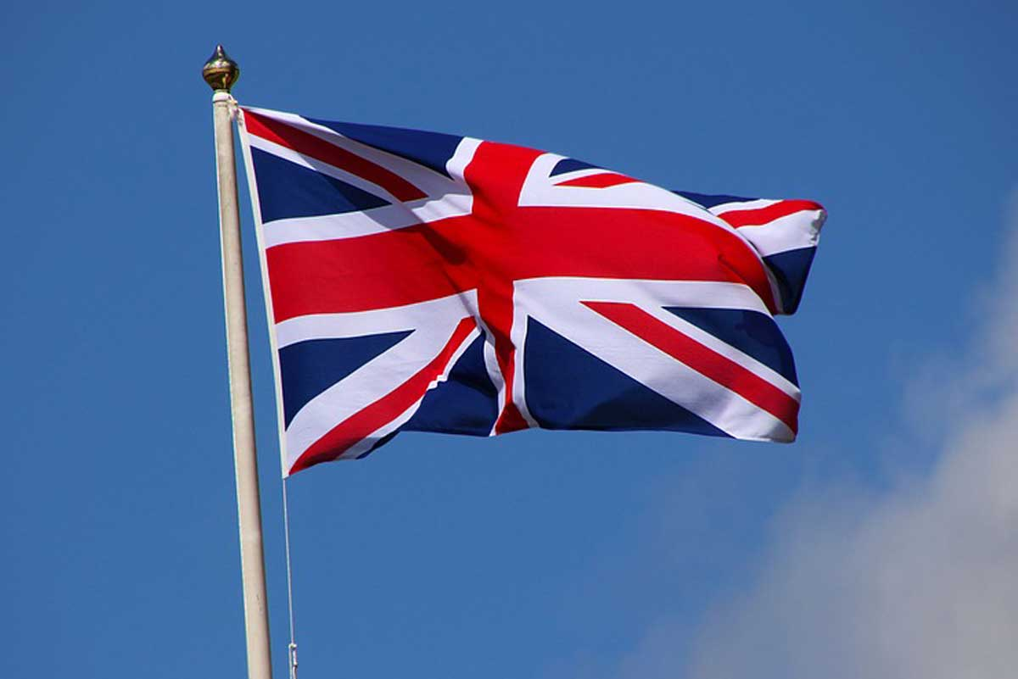 | FLAG:  - The Flag of Malawi is made up of three equal horizontal stripes of black, red and green with a red rising sun in the centre of the black stripe. The black stripe represents the African people, the red represents the blood of martyrs for African freedom, green represents Malawi's ever-green nature and the rising sun represents the dawn of freedom and hope for Africa.  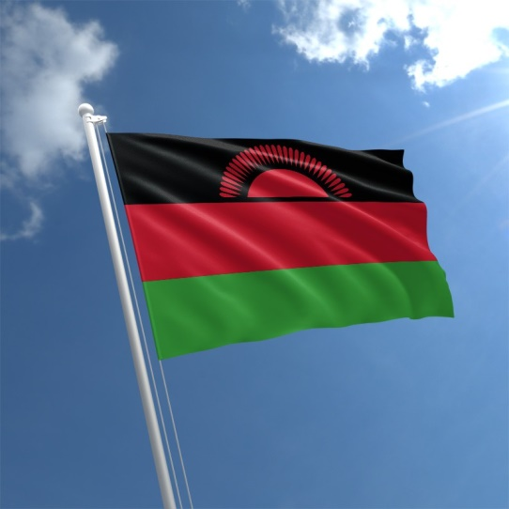
HISTORY:  - Minchinhampton is an ancient market town.  - The town's shops, clustered in and around the High Street, include a general store, two hairdressers, a chain store, a ladies' boutique, a butcher's, a local organic dairy outlet, two restaurants, a cafe, a post office, an estate agency, and several charity shops.  - The town also has doctors' and dentists' surgeries, a public library, a school and a youth club.  - The Crown Inn closed unexpectedly in March 2014. Its location in Market Square made it a focal point for the Minchinhampton Country Fayre, held every other year. However, it reopened in November 2019.  - The main square has a War Memorial, and a 17th-century Market House, given to the town in 1919 by the Lord of the Manor, Lt Col. H. G. Ricardo, and restored in 1944. A market is held every Thursday.  - There is a summer visit by Gifford's Circus every year.^{[3]}  - Minchinhampton has two places of worship: the Anglican parish church of the Holy Trinity Church, and Minchinhampton Baptist Church. | HISTORY:  - In 1891 the area was colonised by the British. In 1964 Malawi became an independent country under Queen Elizabeth II with the new name Malawi.  - Malawi now has a democratic, multi-party government headed by an elected president.  - In January 2015, southern Malawi was devastated by the worst floods in living memory. These floods affected more than a million people across the country.  - In 2016, Malawi was hit by a drought, and in January 2017, the country reported an outbreak of armyworms around Zomba. The moth is capable of wiping out entire fields of corn, the staple grain of impoverished residents. On 14 January 2017, the agriculture minister George Chaponda reported that 2,000 hectares of crop had been destroyed, having spread to nine of twenty-eight districts.  - On 16 August 1914, Lake Malawi was the scene of a brief naval battle when the British gunboat SS Gwendolen, destroyed the German Empire's only gunboat on the lake, the Hermann von Wissmann. This very brief gunboat conflict was the British Empire's first naval victory of World War I.  - The 25 km solo swim across Lake Malawi has been accomplished on 5 occasions by 14 swimmers.  - In 2019, Martin Hobbs (SA), became the first person to swim the full length of Lake Malawi (54 days), as well as setting the world record for longest solo swim in a lake.
ECONOMY: (making and trading things of value)  - The UK is a rich country.  - The UK is the sixth largest economy in the world.  - The UK makes it money from services (doing things for other people), then manufacturing (making things to sell) and then agriculture (farming). | ECONOMY: (making and trading things of value)  - Malawi is a poor country.  - It is among the world's least-developed countries. The economy is heavily based in agriculture (farming), with a largely rural population that is growing at a rapid rate. The Malawian government depends heavily on money from other countries.  - Malawi produces tea, sugar and coffee.
EDUCATION:  - The Victorians came up with the idea that all children should go to school instead of working. Only rich children were taught how to read and write.  - It wasn’t until 1880 that it became mandatory for children to go to school. All children had to attend school until they were 10 years old. In 1889, the school leaving age was raised to 12. In 1891, schools became free.  - There could be as many as 80 pupils in one class! The teachers were very strict. Children were often taught by reading and copying things down, or by chanting things until they were perfect. | EDUCATION:  - In 1994, free primary education for all Malawian children was established by the government, and primary education has been compulsory since 2012. As a result, attendance rates for all children have improved.  - Attendance for secondary school is not as good as for primary, with attendance rates being slightly higher for males.

