**Imagine you are strapped into the Virgin Galactic, ready to take your first trip into space.**

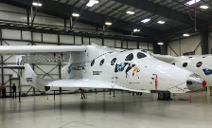

*Source: Steve Jurvertson*



Describe the Virgin Galactic. What does it look like? What is it like inside? Is the seat comfy?

Is your journey orbital, suborbital or lunar?



What is your body doing?

What can you see, hear, smell?

How do you feel?





What are the other people on board doing?

**Write a diary entry about your flight on Virgin Galactic.**

How does your journey end? Do you make it back to Earth? Do you discover another planet?

Describe what you can see, hear, feel.