Playdough recipe
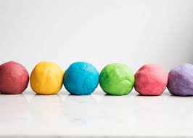

This is a simple no-cook recipe. Various things can be added to increase the sensory experience eg:

Smell – add a scent using essential oils, dried or fresh herbs and spices, lemon juice, coffee, cocoa powder etc (but watch carefully when playing as these make the playdough even more tempting to eat!!!)

Texture – could add rice, glitter, sand, sequins, flowers, seeds etc.

Ingredients:

- 2 cups flour
- 4 tablespoons cream of tartar
- 2 tablespoons vegetable oil
- 1 cup salt
- 2 cups boiling water (adult will need to do this part)
- Few drops glycerin
- Food colouring

Method:

- Mix together the flour, cream of tartar and salt in a bowl
- Add food colouring to the water (before you add to the main mixture)
- Add the oil and water (with food colouring) and keep stirring until it all comes together
- Add any extras you would like (smell/texture)
- Leave in the bowl to cool and don’t worry if it still looks gooey
- Once cool enough add to a dry surface and knead, knead, knead. This is really important and helps to get rid of the stickiness
- Add a few drops of glycerin and knead them in
- Play
- Store in an airtight container or ziplock bag and it will last for weeks. We generally store ours in the fridge.

