Mindfulness ideas

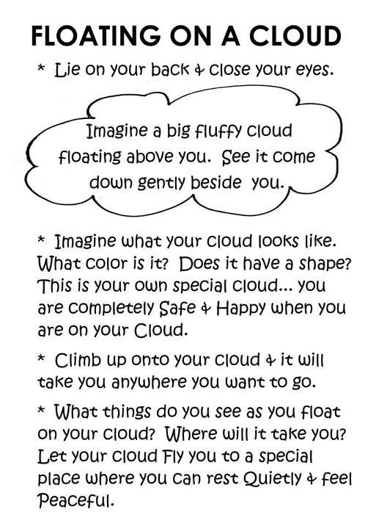

- Go on a mindful walk - taking careful note of all the things you can see, smell and hear on the walk

- Cloud watching. Lie down on your back outside. Look carefully at the clouds in the sky. What shapes can you see? Do they remind you of anything?

- Sounds. Lie on your back outside. Close your eyes and listen carefully. What sounds can you hear? What do you think they are?

- Lie down on the floor on your back. Place a duplo brick or a soft toy on your tummy. Take deep breaths in and out and watch the brick or toy move up and down slowly. Close your eyes and concentrate on your breathing in and out. [This is one of our favourites at Nursery. We turn the lights off and the children do this for approx. 5 mins]. It is a nice way to slow things down.

- Becoming superheroes – another popular one at Nursery! (see attachment)

- Frozen themed mindfulness. Focus on breathing by building ‘Elsa’ ice sculptures by taking in a deep breath (not forgetting to smell the chocolate fountain on coronation day!!) and then slowly breathing out to create amazing ice creations in the sky.

Therese Watt
Nursery Manager

